Date | 03 October 2026
Team ID | SWTID-2026-7735
Project Name | Auto Ticket Classification using Flow Designer
Maximum Marks | 4 Marks

Project Design Phase
Solution Architecture
Solution Architecture:
Solution architecture bridges business problems and technology solutions by defining component interactions across tiers.
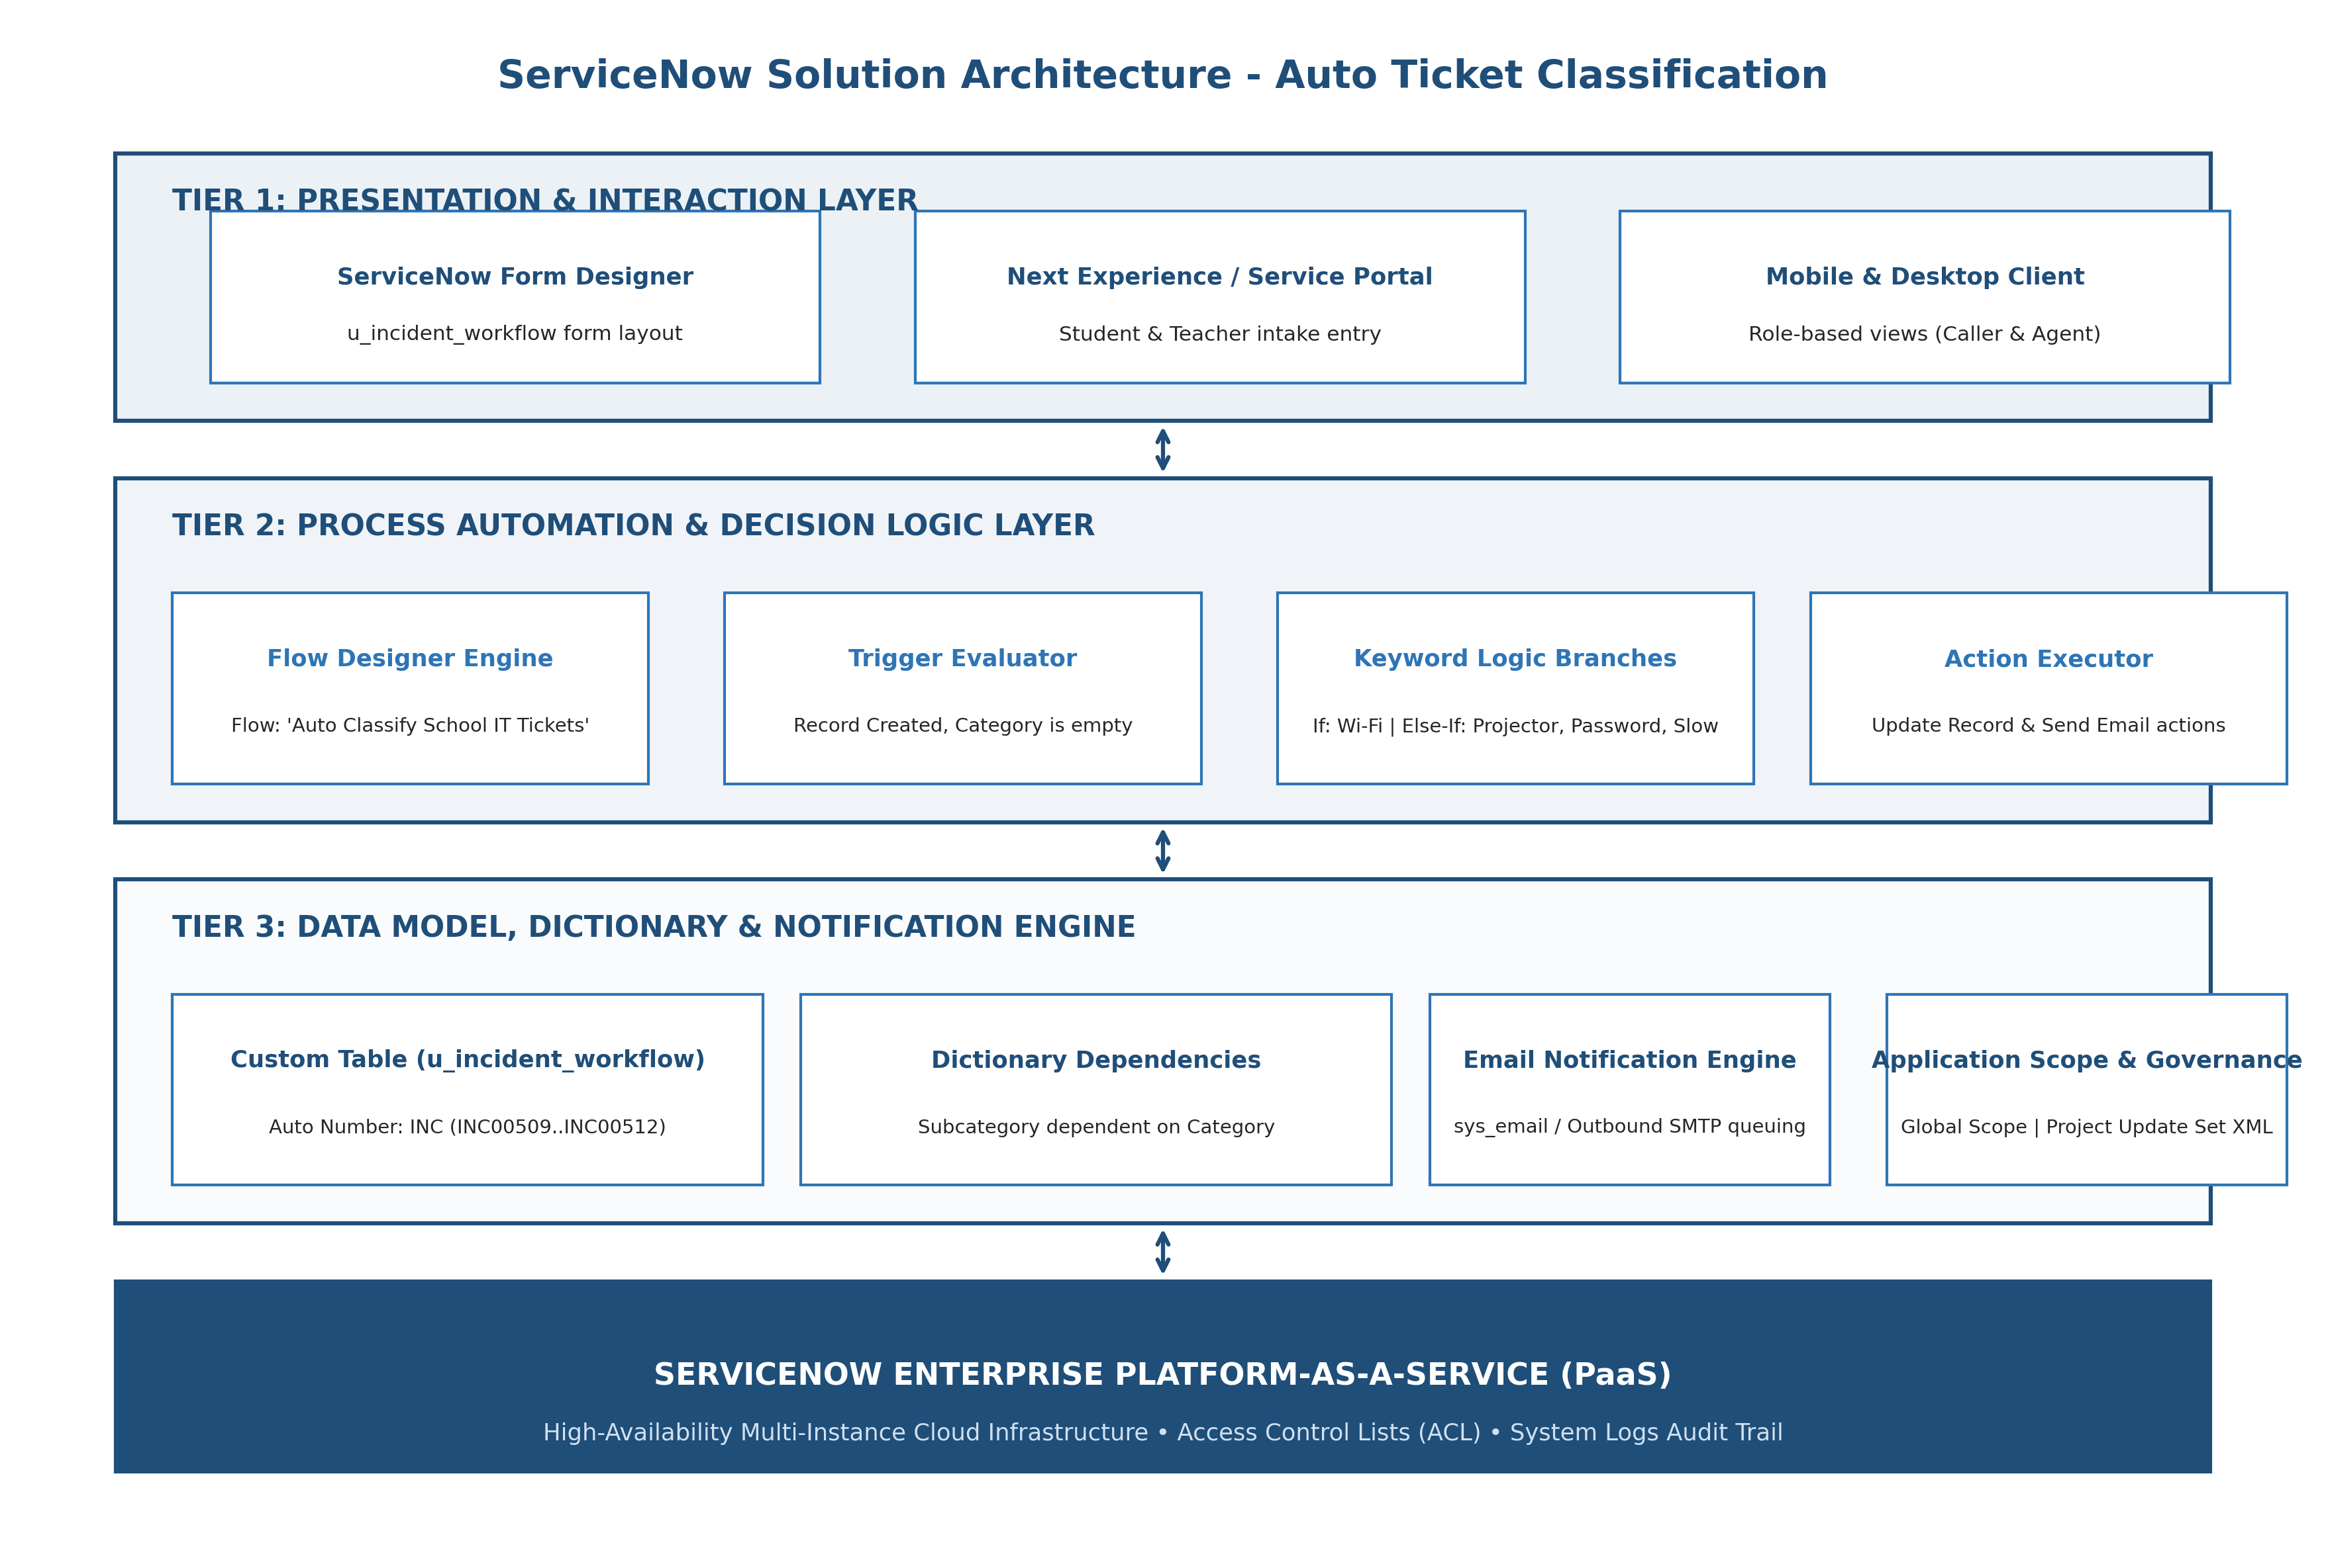
Figure 3.2: Multi-Tier ServiceNow Solution Architecture Diagram
Architectural Breakdown:
- 1. Presentation Layer: Form Designer UI exposing Caller, Short Description, Category, Subcategory, State, and Assignment Group on table u_incident_workflow.
- 2. Event Trigger Layer: Flow Designer Trigger firing on Record Created where Category is empty.
- 3. Decision & Logic Layer: Natural branching logic: Wi-Fi/Network -> Network/Wi-Fi; Projector -> Hardware/Projector; Password -> Access/Forgot Password; Slow Computer -> Performance/Slow Computer.
- 4. Persistence Layer: Custom table u_incident_workflow with Auto-Numbering (INC prefix) and Dictionary Dependent choices.
- 5. Notification Layer: Flow Designer 'Send Email' action dynamically resolving Caller -> Email.
- 6. Governance Layer: Tracked in 'Project Update Set' and exported as XML payload.

